**Project Design Phase-II**

**Data Flow Diagram & User Stories**

|  |  |
| --- | --- |
| Date | 20 June 2025 |
| Team ID | LTVIP2025TMID28652 |
| Project Name | Educational Organisation Using ServiceNow |
| Maximum Marks | 4 Marks |

**Data Flow Diagrams:**

A Data Flow Diagram (DFD) is a traditional visual representation of the information flows within a system. A neat and clear DFD can depict the right amount of the system requirement graphically. It shows how data enters and leaves the system, what changes the information, and where data is stored.

A Data Flow Diagram (DFD) for an educational organization using ServiceNow would illustrate how data moves through various processes within the system, including student information, course enrollment, faculty data, and administrative tasks. The DFD would visually represent entities like students, faculty, and administrators as external entities, with processes like registration, course management, and reporting being represented as circles or rounded rectangles. Data stores, such as student databases, course catalogs, and financial records, would be shown as open-ended rectangles, and data flows would be indicated by arrows, showing the direction of data movement.

Here's a breakdown of key components and potential DFD elements:

**External Entities:**

**• Students:** Interact with the system for registration, course selection, accessing grades, and submitting assignments.

**• Faculty:** Manage courses, enter grades, update student records, and communicate with students.

**• Administrators:** Manage user accounts, configure the system, generate reports, and oversee overall operations.

**• Parents/Guardians:** May interact with the system to view student progress, pay fees, or communicate with the school.

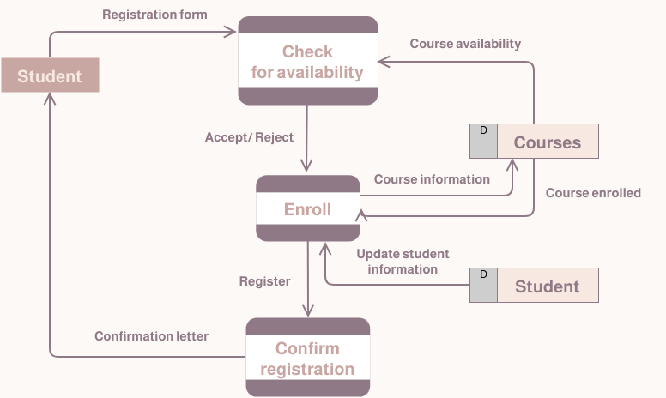

**Processes:**

• Registration: Handles student enrollment, course selection, and related data entry.

• Course Management: Enables faculty to create, update, and manage courses, including content, assignments, and grading.

• Grade Management: Allows faculty to input and update student grades, and for students and administrators to view them.

• Communication: Facilitates communication between students, faculty, and administrators through announcements, email, or other channels.

• Reporting: Generates various reports on student performance, course enrollment, financial data, etc.

• Financial Management: Processes payments, manages tuition fees, and generates financial reports.

• User Management: Handles user account creation, access control, and permission management. [3, 4, 5, 6, 7, 8, 9, 10]

**Data Stores:**

**• Student Database:** Stores student personal information, academic records, enrollment history, etc.

• Course Catalog: Contains information about available courses, descriptions, prerequisites, etc.

**• Faculty Database:** Stores faculty information, teaching assignments, and contact details.

**• Financial Records:** Keeps track of student fees, payments, and other financial transactions.

**• System Configuration:** Stores system settings, user roles, and other administrative data.

**Data Flows:**

• Arrows indicating the direction of data movement between entities and processes. For example, an arrow from "Students" to "Registration" would represent student registration data being input into the system. Another arrow from "Registration" to "Student Database" would indicate that the student's information is being stored. [2]

**Context Diagram (Level 0 DFD):**

A context diagram provides a high-level overview of the system. It would show ServiceNow as a single process and all external entities interacting with it. The context diagram is the starting point for creating more detailed DFDs.

**Level 1 DFD:**

A Level 1 DFD breaks down the "Registration" process into more detail, showing how data flows between sub-processes like "Enter Student Information", "Select Courses", and "Confirm Enrollment".

**Example:**

A student registers for a course. The student provides their information (data flow) to the Registration process. The Registration process stores the student's information in the Student Database (data store) and updates the Course Enrollment records. The Course Management process then accesses the updated Course Enrollment data to manage the student's course load. This flow is represented by arrows indicating the direction of data movement. [By visually representing data flows, a DFD helps to clarify how data is used and managed within the ServiceNow system, improving understanding and facilitating communication among stakeholders